**Project Development phase**

**Project Development delivery of sprint 3**

|  |  |
| --- | --- |
| Team ID | PNT2022TMID50823 |
| Project name | Smart crop protection system for agriculture |

**Flow chart:**

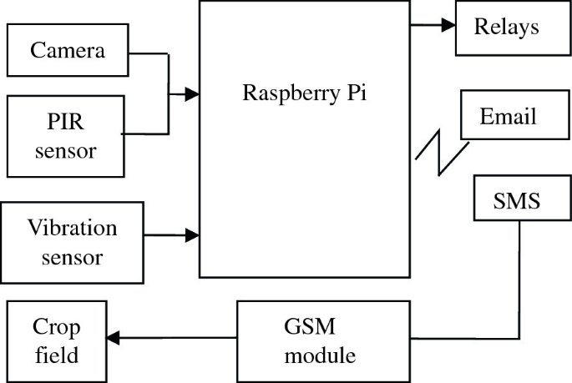

**Concept:**

Crop protection is the general method or the practice of

protecting the crop yields from different agents including pests,

weeds, plant diseases, and other organisms that cause damage

to the agricultural crops.

**Advantages**

* Remote Management. With farms being located in far-off areas and distant lands, farmers are seeking a better solution to their management issues. ...
* Real-Time Crop Monitoring. ...
* Crop Protection. ...
* Soil Testing & its Quality. ...
* Real-time Analysis of Soil Demand. ...
* Smart Greenhouses.